**Expert ID/Name: Nstructive**

**Date: 20-Nov-2020**

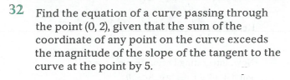

**Answer:**

|  |
| --- |
| **Section 1:** Algorithm/Theorem Reminder / A tip for solving these type of questions |
| **Tips:**   1. Convert the given condition into linear differential equation.   2 . Integrating factor of is .  3. General solution of is |

|  |
| --- |
| **Section 2:** Step-by-step answer |
| Given: The curve passing through and sum of the intercepts of the curve exceeds the magnitude of the slope of the tangent to the curve at the point by .  To find: Equation of curve according to given condition.  Step 1:   |  |  | | --- | --- | | Instruction | Convert and Compare the given condition with | | Calculation | From the question,    Compare with |   Step 2:   |  |  | | --- | --- | | Instruction | 1. Integral factor of is. | | Calculation |  |   Step 3:   |  |  | | --- | --- | | Instruction | 1.General solution of is | | Calculation | When      Hence the solution is | |

|  |
| --- |
| **Section 3:** |
| Final answer: The particular solution of  given that when is . |